Accept Manual Quote

Overview

Current processing
Current Manual Quote comes to CBOEDirect through PAR (see old BOB requirement document for detail).

New requirement
PAR user should be able to send Manual Quote (in New Order format) to the SBT system (Trade Engine):
- New Order (representing Manual Quote) will be sent from PAR to SBT.
- SBT will accept and mark that Order as Manual Quote and put into the book.
- This Manual Quote can be on multiple price point and also can be on worse price point.
- Since there will be multiple manual quotes, the manual quote timer will be not be used.
- Display the location Id for first best Manual Quote in the book on the overheads and clear or change the location Id whenever Manual Quote losses priority or gets removed (either traded out or Cancels) and another Manual Quote becomes best.

Assumption
- PAR user will send the New Order (Simple Options Order) through CAS that will represent each Manual Quote.
- There will be some indication on the Order (e.g. Extensions field) that this is Manual Quote.
- This Order will skip all routing check will always go to Trade Engine.
For detail please refer to Requirement document.

Implementation
The new classes that will be implemented for this functionality are:
- WFStepCheckManualQuote – Check if this Order represents Manual Quote, needs directly to be routed to Trade Engine.
- BrokerManualQuoteStrategy – This will be the new Strategy to processes new Manual Quote.
- ConsolidatedManualBookImpl – This is a light weight Manual Book that maintains the Location Id, price of the first best Manual Quote and aggregated quantity of all other Manual Quote at that price (if any) whenever refresh Book call is made.

Main Flow
- Once we receive Manual Quote in OrderEntryServiceDelegateImpl do the necessary formatting/parsing of Extension Field with Location ID and mark the Order as Manual Quote. And then validate it.
- In the Workflow after activating the Order and publishing new event skip all other routing checks and send this direct to Trade Engine after appending the Handling Instruction as - TradingRestrictions.NONE & RemainderHandlingModes.BOOK_REMAINDER.
- Also log the appropriate Order History.
- After the Manual Order reaches AcceptOrderCommand, it calls BrokerProcessorHybrid2Impl to processOrder.
- This will check to see if the Manual Quote is marketable to opposite side market then this Order will be cancelled with reason.
- That will call processOrderWithoutRefreshBook on BrokerProcessorBase this in-turns will find strategy BrokerManualQuoteStrategy.
- If this Manual Quote is marketable with auctioning Order then it will trade first and expire the auction (if need be) and the book the Manual Quote into regular Order Book if quantity left (handling of Manual Quote for ongoing auction will be covered separately).
- After booking the Manual Quote processRefreshBestBook will be called on BrokerProcessorBase that calls refreshBestBookWithLock on OrderBookImpl that will call ConsolidatedManualBookImpl through OrderBookEditor to reconcile the Location Id, price and quantity for ManualQuote if this books on top. And respectively publish appropriate Current Market, and Accept Manual Quote (for MDB Adapter) and also Market Data History.

Alternate Flow
- If Manual Quote was thrown back from Trade Engine because of any reason this reject will propagate back to the originating PAR user.
- If Trade Engine is down the Manual Quote will be reject back to the user.

Scripts
- None

Database
- None

SetContext

XML/DTD

Homes/Services
- WFStepCheckManualQuote
- BrokerManualQuoteStrategy
- ConsolidatedManualBook, ConsolidatedManualBookImpl

ImplPlan
- Flow Diagram
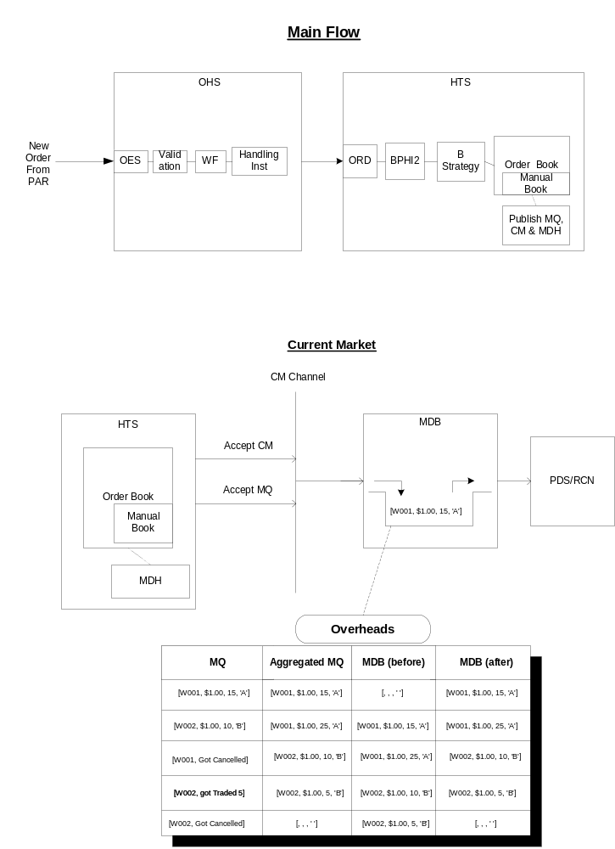
- Sequence Diagram
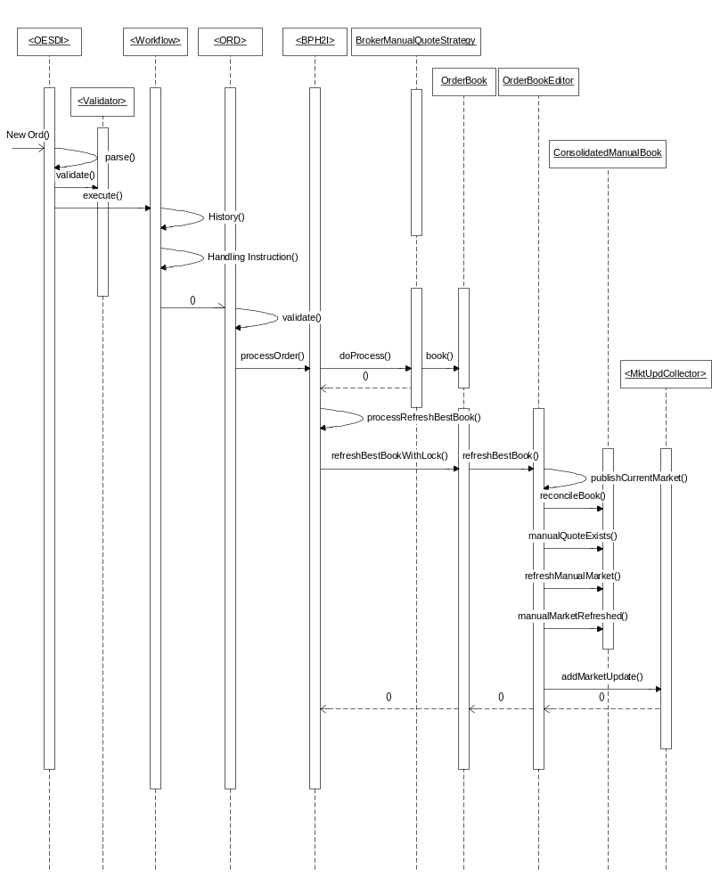

- Class Diagram
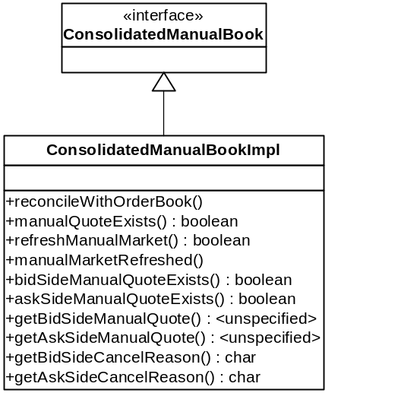

PerformanceTestingProcedure
- .

TestingProcedure

OperatorProcedure
- .

Fallback/Failover

